

Strategic Engagement Plan

Draft Version July 2017

### Goals and Objectives………………

### Part 1: Engagement…………………………..

### Part 2: Outreach………………………..

### Part 3: Communications………………………

### Part 4: Information Management……………………….

### Appendix

### Timeline………………………………

### Services…………………………………

### Management………………………….

### Templates……………………………….

# Goals and Objectives

The following strategic engagement plan was created to

1. Help steer the development and management of GHHIN from 2017-2021.
2. Lay out a strategic roadmap for engaging stakeholders targeted outreach, key messaging, and services offered.
3. Present network organization and functionality as an integral aspect of engagement, sustainability, and capacity building.

The core components of GHHIN are the website and its associated services. This report provides a roadmap to develop, implement, and sustain these components. This report is broken into

Part 1: Engagement – Target audiences, strategies for engagement and participation.

Part 2: Outreach – Design, marketing, and outreach instruments.

Part 3: Communications - Targeted messaging .

|  |
| --- |
| Report Objectives |
| Identify, synthesize, and communicate evidence and lessons learned, and propagate good practices across the network and with other scientists, policy- and decision-makers. |
| Mobilize and improve access to expert resources and opportunities for learning, exchange, and engagement. |
| Facilitate the generation of actionable evidence and information vis-à-vis activities to develop, share, and promote standardized technical guidance, research, data, and decision-tools. |
| Help members use available evidence to promote critical action for the global network, its partners, and activities |
| Produce and manage a centralized information hub for heat health. |
| Identify and communicate pressing heat health research gaps |

Part 4: Information Management – The process of information collection, synthesis, and dissemination.

## Phases

The development of GHHIN has been broken into three phases which indicate strategic and feasible network objectives and assist in network development and management capacities. The phases are the following:

1. Pre-implementation: tools, strategy, brand.

The pre-implementation phase consists of laying the foundation necessary to implement GHHIN successfully. This includes constructing tools, designing and developing services, and creating the GHHIN brand. The GHHIN site will need to be designed and tested, and initial outreach and capacity building will be needed to support the GHHIN steering committee. These tasks will be carried out by the WHO/WMO development and coordination team.

1. Capacity Building (0-2 years)

Capacity building outreach will be comprised of targeted outreach to key stakeholders, such as leading experts, policy makers, or institutions/organizations identified through the GHHIN steering committee and online searches. We expect self-selected applicants as a result of GHHIN branding, which will contribute to the diversity of members.

1. Sustainability Outreach & Marketing (2-4 years)

Once regional nodes have been established, recruitment responsibilities will largely fall on nodes to actively recruit new members from participant’s social and professional networks. WMO/WHO will continue to perform targeted recruitment when the coordination office identifies new stakeholders. However, this will not be a priority focus of the coordination office. The website will provide accessible services to streamline recruitment such as offering links to share content and recruitment resources via social media, email, etc.

## Performance Indicators

The success of GHHIN will be based on its direct relevance and usefulness to its target audiences, consistent growth, the quality of interactions between users, and the network’s sustainability. GHHIN utility will be measured on whether the information and knowledge services help to produce measurable change in policies and programs, foster collaborative projects between users, direct research towards heat health research gaps, and ultimately reduce the health impacts of extreme ambient heat.

Several potential indicators for GHHIN could be the following:

1. The number of registered members.
2. The number of monthly contributions/traffic to site.
3. The number of attendants to forum.
4. The number of unique intra-network communications between members of unique audience groups.

# Part 1: Engagement

## Target Audiences

The GHHIN aims to bring together several different audiences around a common interest in heat health.

## Primary audience for GHHIN:

1. Experts:

The expert audience includes all individuals and institutions which produce and disseminate research relevant to the GHHIN project. This could include researchers, academic institutions, and experts on topics related to heat health. This audience is important for GHHIN to engage with, in order to connect decision makers and practitioners with appropriate research and connect researchers with institutional support from practitioners and decision makers. Experts will use GHHIN to share and disseminate their research, engage with other audiences, and find projects and develop partnerships.

1. Decision-makers:

The decision-makers audience includes all individuals and institutions which make decisions that influence others in regards to GHHIN related topics. This could include politicians, administration, employers, and many more. It is important for GHHIN to engage this audience so that heat health decisions are guided by current research and on-the-ground practitioner input. Decision-makers will utilize GHHIN to access the research on heat health, work with research to answer pertinent heat health questions, garner input from practitioners, collaborate on projects and develop partnerships.

1. Practitioners:

The practitioner audience is comprised of individuals and institutions that work with individuals affected by extreme ambient heat. This could include medical staff, social service organizations, information users, social workers, emergency service workers, and many more. GHHIN seeks to engage this audience to gather and facilitate the creation of case studies, input, and lessons learned materials from heat health related programs and projects. GHHIN seeks to connect this audience with researchers – to help shape research and practice, and with decision makers, so that decisions on heat health are made with a firm understanding of the on-the-ground realities of hazards, exposure, and vulnerabilities.

## Secondary audience

1. Media

Media is not a primary audience for GHHIN, but will be indirectly engaged. Through providing resources for media via the GHHIN website, the media will assist in the dissemination of member projects, heat health related research, and other pertinent information.

1. General Public

The general public is not a primary audience of GHHIN, but similar to the media, will be indirectly engaged through the website and social media accounts. The general public will be able to access information and disseminate information via social media sharing, to spread news about GHHIN activities, research, and the dangers of extreme ambient heat. The general public will also assist in GHHIN recruit by informing heat health experts, decision-makers, and practitioners who are not within the social networks of GHHIN members.

## Engagement Terms

GHHIN members will be expected to meet the following requirements, and will be informed of such expectations prior to recruitment:

1. Agree to be contacted by other GHHIN members.
2. Complete the intake form – name, expertise, org, relevant work, what they want from GHHIN.
3. Contribute to the shared knowledge and organization of the database – identify and categorize submitted work according to the GHHIN tagging system.
4. Invite stakeholder participation from their social network.
5. Agree to participate in GHHIN events (website, conferences, webinars).

# Part 2: Outreach

The GHHIN outreach section is broken into the following subsections:

1. Participant services
2. Design principles, marketing and strategy
3. Outreach instruments
   1. Website
   2. Social Media
   3. Listserv
   4. Forum

## Participant Services

To facilitate knowledge, collaboration, and action in the heat health domain, GHHIN offers the following objectives oriented services:

**Heat health information hub:** GHHIN website will be a heat health information hub, offering tools, services, and resource connections to promote collaborative learning and partnership development between members (appendix 1). The website will highlight identified priorities in action and research, collect user knowledge, track heat health research, and provide a centralized location for heat health information and information tools.

**Knowledge broker services:** The GHHIN will act as a knowledge broker – facilitating on-going dialogue between knowledge creators, and knowledge users. The GHHIN instruments – website, social media, etc. will act as vehicles for the exchange and analysis of heat health information. GHHIN will prioritize the communication of policy needs and recommendations to key decision-makers, and supporting gap filling activities that add value to member’s work, such as creating a mentoring programs, managing a crowd-sourced heat health action database, and tracking and disseminating heat health news. (appendix 1)

**Member collaboration**: GHHIN will offer services tailored to the promotion of information sharing and partnership development. These include services such as country, region/city, member, and organization profiles. Through the management of website data – such as tracking capabilities, GHHIN will offer users the ability to identify relevant heat health informants, partners, and research collaborators.

**Bi-annual conference**: A central identified heat health gap is the absence of a global heat health synthesis report, and a forum for global heat health stakeholders to share information on the topic. In addition to the website, GHHIN will fill this gap by hosting a bi-annual global heat health forum, and through the information shared, compiled, and analyzed on the website will create a bi-annual global heat health synthesis report. These activities will be supported by technical heat health working groups comprised of identified GHHIN members with expertise in the respective field of their working group.

**Global synthesis report:** A central identified heat health gap is the absence of a global heat health synthesis report, and a forum for global heat health stakeholders to share information on the topic. In addition to the website, GHHIN will fill this gap by hosting a bi-annual global heat health forum, and through the information shared, compiled, and analyzed on the website will create a bi-annual global heat health synthesis report. These activities will be supported by technical heat health working groups comprised of identified GHHIN members with expertise in the respective field of their working group.

## Design Principles

**Information Dissemination:** Integral toGHHIN’s success is the extent to which the network inspires member participation. Several services (appendix 1) and strategies will be implemented to encourage users participation:

1. Website design – which creates shareable content, and allows for accessible sharing and recruitment options.
2. User-centered services.
3. Social media presence that garners brand recognition and attention to member activities.

GHHIN’s design principles:

* User-intuitive navigation adapted for a diverse set of users
* Provide relevant tools for varied heat health stakeholders
* Provide access to information and knowledge that can be tailored to local context
* Retain a sense of ownership by the heat health community
* Build interest so that users share more knowledge online
* Streamline finding pertinent heat health content
* Foster inter-organizational and individual member collaboration
* Create a centralized hub for information retrieval, analysis, and dissemination
* Adapt the site contents based on continual user feedback

## Design Process

The GHHIN development and implementation process will evolve between 2017-2021. Fundamental site components will be updated and new services will be added. Priority areas of work include the development of the website, and building a social presence amongst heat health decision makers, practitioners, and experts. Selected services will gradually be introduced over the four years, prioritizing services that are tailored to meet GHHIN objectives. (appendix 1) A GHHIN steering committee was formed in 2015, which has guided the development of the network’s foundational content. This strategic engagement plan will be revisited and updated as needed.

**Site architecture**: The website architecture will be developed in two phases. The first phase will provide the base architecture needed for the 0-2 year services (appendix). The second phase will require a web developer who can create the user centered infrastructure needed for the 2-4 year services (appendix). Rigorous site testing will be implemented throughout phase 1 and phase 2 to ensure user accessibility and service functionality.

**Brand:** One of the first priorities for GHHIN is to become a known and trusted brand amongst the heat health community. GHHIN will foster a reputation as a trusted source for heat health information and a neutral facilitative platform to connect members and share knowledge. GHHIN site sections will reflect the GHHIN brand by offering a user-centered, organized, modern look that avoids frivolous materials and graphics. The website will effectively highlight the GHHIN objectives, services, allow for easy content and site sharing, and provide a responsive design for mobile users.

## Outreach Marketing

The GHHIN outreach marketing is best understood in relation to the GHHIN phases:

**Phase 2 (0-2 years)**

The first phase focuses on building the GHHIN brand and recruiting a diverse and competent assembly of active members. This is addressed through key messaging tailored to the interests of target GHHIN audiences, and an evolving iterative outreach process that changes according to the capacity and sustainability of the network. Outreach marketing and recruitment during phase 1 will be the primary responsibility of the WHO/WMO coordinating office.

**Phase 3 (2-4 years)**

The second phase focuses on a process of management decentralization shifting responsibilities, such as decision making to regional node control. During phase 2 marketing outreach and recruitment will become the primary responsibility of the regional nodes and respective members. The two phase system will require periodic assessment and adaptation according to the evolving needs of the network. (Appendix 2, 4)

## Member Strategy

The initial capacity building stage of GHHIN recruitment will consist primarily of targeted outreach/snowballing recruitment methods, member’s social and professional networks, and relevant applicants who register via the website. This will build regional capacity, expertise, and guarantee a level of diversity required to promote an interdisciplinary network of heat health stakeholders. Targeted outreach will be focused on GHHIN steering committee recommendations and generated contact list.

## Website

The website is a central product of GHHIN – acting as a virtual meeting space that facilitates member collaboration, intra-network communication, knowledge sharing, and the development/dissemination of best practices. The website is designed to support the overall objectives of the GHHIN, however more specifically the website aims to:

* Improve access to heat health information for diverse professional communities in the same place and thereby improve connectivity of multiple disciplines and sectors.
* Raise awareness of the interconnectivity of climate, extreme ambient heat, and health and the value of climate and health information in decision making.
* Promote and provide evidence-driven interventions, shared-learning, and the co-production of information through participant collaboration.
* Provide decision support and learning tools to help members identify services and resources; help partners appropriately tailor their products to meet the needs of various sectors.
* Compile and showcase experiences, best practice, and opportunities to develop heat related services.
* Compile and synthesize research and in-field experiences from a variety of sectors, to promote the development of best practices, and more effective and informed life-saving preparedness and planning measures.
* Identify human resource and expertise through submissions, member profiles, and regional nodes.
* Inform the creation of a bi-annual global heat health information report.
* Build research capacity, identify research gaps, and act as a knowledge broker between sectors and institutions.
* Promote and highlight member research, program implementation, and collaborations that address issue related to heat health.

The website will achieve these aims and objectives through its content, features and recruitment strategies.

## Website Aspiration

To establish the GHHIN brand as a user-friendly, credible, information sharing collaborative platform for the heat health community. As the go-to reference site for global heat health information – the website will help harmonize and improve information and opportunity sharing across burgeoning local communities of health professionals, decision makers and scientists motivated to address this issue. It will enable users to collaborate on projects, disseminate heat health research, contribute to the bi-annual global heat health synthesis report, and help accelerate progress in the field.

## Website Content

The site will contain three main categories of content areas: 1) the public content area – which will be accessible to everyone; 2) GHHIN member only content area – which will only be accessible to GHHIN members assigned a password; 3) the node-only member content area – which will only be accessible to GHHIN members with node specific passwords.

These content areas will be comprised of the following pages:

General Public:

1. GHHIN website home page will provide a summary of the network, login link for members, and display live feed. The home screen page will also contain navigation links to the other public pages found below. (Appendix 3)
2. Live-feed banner of relevant news, events, and highlighted projects.
3. WHO/WMO Heat health page providing an overview of the link between heat and health, why it is important and how it will become more important in the face of a changing climate.
4. GHHIN background page explaining the purpose of the network, who can join, and its history.
5. Node information page which shows functioning nodes, and explains node functions. This will promote regional node projects.
6. Conference and Synthesis Reports page which will provide a central location for the general public to access past and current GHHIN synthesis reports and past conference reports.
7. Membership application page which will explain who can become GHHIN members and provide a short, in page application process that will automatically send submissions to the managing team.
8. Join GHHIN page will consist of the strategic engagement key messaging points, and provide a link to the online application form.

GHHIN Members:

1. Members Log-in page will be password protected. The page will be directly accessible from the GHHIN home screen (Appendix 3). Each member will have a unique password assigned to them upon becoming a member. Members who are assigned to nodes – recognized through the application process, will be able to access node specific pages with their login passwords. Members who are not assigned to a node, will only be able to access the member pages, but not the node pages.
2. Members-only home screen page will provide a centralized “news feed” of important information regarding heat health and GHHIN, such as relevant forecasts, upcoming GHHIN events and conferences, and posts from the GHHIN twitter account. The members-only home screen will provide a navigation bar containing links to the members-only pages below. (Appendix 5)
3. How-to-use GHHIN page will offer instructions on how to navigate and use the GHHIN platform, such as tagging posts for visibility of content. This page will be recommended for new members, and a link to the page will be provided in the membership acceptance email.
4. Member Profiles page will list all GHHIN members according to node, with a section of non-node assigned members. Each member name will offer contact information, obtained through the membership application process. All participating GHHIN members will agree to be contacted by fellow members. Each member will select which tags they are associated with – expertise, interests, profession, location. Profiles will also directly link to submitted content. (Appendix 10)
5. Country Profiles page (appendix 6, 7)
6. Heat health database (appendix 9)
7. GHHIN Publications page will offer a centralized location for all the GHHIN synthesis reports, with the most recent report being most prominent. The page will also provide conference reports (Appendix)
8. GHHIN Calendar page will provide an embedded google calendar, displaying upcoming GHHIN video calls, and upcoming conferences. This will include node specific meetings. The calendar will provide a link for users to automatically get alerts when there is an upcoming event.
9. Information sharing page will provide links to relevant databases, and heat health tools.
10. Support Desk page will provide a phone number and/or direct email link to the live support desk service.
11. GHHIN Regional Node page will provide a link to all participating GHHIN nodes – represented by the node name overlaid onto an image of the node region. The node page will also contain dulled out images of non-participating nodes – which when selected will offer instructions on how to set up a new node (directing interested parties to contact the GHHIN support desk). Each node image will be a link to the node-specific pages, only accessible to members with node accessible passwords. (Appendix 5)

Node Members

1. The node content areas will have access to the same content areas/services as the main GHHIN members pages, however, node content and content areas will be tailored to node needs and capacities and these development responsibilities will be up to the identified node host organization to carry out.

Each GHHIN content area will be developed with the goal of strategically meeting the GHHIN objectives - creating a useful, user-friendly, seamless website that promotes user participation, collaboration, and information analysis and dissemination.

## Website development and growth

The website will continue to grow and develop over the next 5-10 years after the initial framework has been created and launched. This content will partially be initially generated and maintained by the WHO/WMO office, but will transition to sharing management and funding to the regional node. Feedback from GHHIN users will dictate the content and framework that is needed and most useful. The development of the new content can occur concurrently to the development of the initial website with the idea that the new content will be added shortly after the initial launch. This content development will require dedicated human resources. Other content can be created alongside other work e.g. video content of projects, meetings, and explanatory videos/animations.

## Social Media

The WHO/WMO coordination office will create a specific social media Twitter account, to share up to date information on heat health, showcase GHHIN member projects, collaboration, and research, and establish a presence amongst heat health stakeholders. As such there needs to be mechanisms to source and collate this information. Two possible methods include setting up automatic and directed feeds from google alerts, google scholar, and others, through established methods (widgets and RSS feeds).

The Twitter account will also be used to recruit members, and provide a communications line to interested parties, practitioners, media, and the general public. The Twitter feed will be directly displayed on the GHHIN website (public and member pages): share GHHIN content, and will also populate a filtered RSS feed from input websites to automatically share up-to-date information on heatwaves and heat health.

## Listserv

The WHO/WMO coordination office will create a GHHIN listserv which will provide bi-weekly digests to members and the general public, containing relevant heat health news, updates on GHHIN, and promoting the work of GHHIN members.

## Forum

The GHHIN bi-annual forum will provide a space for leading experts, practitioners, and decision makers to discuss new developments in the field of heat health, and contribute to the next edition of the bi-annual global synthesis report.

# Part 3: Communications

## Understanding Stakeholder Needs

In recognizing that GHHIN members will have different objectives and needs, this document has organized the targeted key messages for recruitment and outreach according to specific demographic needs —policymakers; healthcare professionals; met services, academics, and the private sectors. The objective of these key messages are to frame GHHIN in a way that speaks to the needs of different sectors, highlighting the potential benefits of joining and actively participating in GHHIN. All outreach to target participants will include key messages that highlight the personal and institutional advantages of becoming a member.

## ****Recruitment Messaging****

##### Decision makers

* + Access empirically supported “best practices” to support effective decisions making.
  + Drive forward thinking economic development and innovation.
  + Garner attention to current and future climate change adaptation efforts.
  + Develop and strengthen multi-sectoral collaboration and support.
  + Connect to potential funding partners.
  + Have access to leading experts and practitioners to help inform effective heat health policies.

##### Experts

* + Create working relationships with heat health decision makers and potential funding sources.
  + Garner attention from decision makers and practitioners to your research and projects.
  + Collaborate with leading experts in a variety of heat related fields, decision makers, and practitioners.
  + Access to a growing database of heat health information and services.
  + Opportunities to put research into practice through collaboration.

##### Practitioners

* + Garner support from experts, decision makers, and potential funders.
  + Contribute to policy and research.
  + Utilize cutting edge research and prevent strategies.
  + Improve multi-sectoral communications and collaboration.

# Part 4: Information Management

GHHIN will act as an information generator, compiler, analyzer, and disseminator. The following input, analysis, and output sections will describe how information is collective, analyzed, and disseminated, but also how this information process will be managed for user accessibility and efficiency. GHHIN will use a tracking system comprised of user generated tags, that will categorize information according to theme, topic, or content. Tags will be created by the WHO/WMO coordinating office to reflect the categories of the GHHIN synthesis report, so that information can be easily extracted from the network and used to update the bi-annual global heat health synthesis report.

## Input

Information will be generated and collected by GHHIN in several ways. Key identified information hubs, such as EM-DAT, Reliefweb, ProVentium Consortium, the Climate Change and Human Health Literature Portal, and others will be identified and contacted to create a knowledge exchange with GHHIN. During the early GHHIN website, these sites will be linked to from the GHHIN content areas, and information will be collected from these sites to share in the network and disseminate through GHHIN social media. Additionally, information will be contributed to GHHIN from user created and identified content. Members will be encouraged to submit research, case studies, and policy papers for member feedback, analysis, and collaboration. All input information will be tagged for categorization and accessibility.

## Analysis

Information input into GHHIN will be analyzed in a variety of ways. Members will be encouraged to utilize shared content in their own work and reach out to fellow members to collaborate, disseminate, and corroborate content. The GHHIN working groups will scrutinize content for the global synthesis reports to promote a high degree of reliability. The WHO/WMO coordinating office will gather information from a variety of sources (see input section) relevant to the GHHIN objectives and focusing on topics related to heat health, and utilize this information to encourage network analysis and feedback.

## Output

Information gathered and analyzed by GHHIN will be disseminated through GHHIN members, GHHIN facilitated content, and the GHHIN website and social media. GHHIN members will be introduced to content via the GHHIN website, social media feeds, and listserv – which will encourage members to share this content or disseminate via word of mouth. Members who produce content facilited by GHHIN – will reflect this information via their research, policies, case studies, etc. GHHIN social media and general public content areas will disseminate information moderated by the WHO/WMO coordinating desk. Lastly, information which has been reviewed, categorized, synthesized, and vetted by an expert team will be disseminated via the bi-annual global heat health synthesis report. This publication will be of limited print, primarily be shared as an online document.

**Appendix**

**Appendix 1**

|  |  |
| --- | --- |
| GHHIN Services | Purpose |
| **0-1 years** | |
| Establish capabilities to track and map active heat waves and their impacts | Provide centralized location for up to date heat and heat health information. |
| Information dissemination – RSS feed, newsletter, twitter account, mailing list. | Establish a social presence amongst ongoing heat health conversations. Disseminate up to date heat health information to stakeholders. |
| Link website to relevant global heat tools and resources | Connect heat health stakeholders relevant resources and heat health tools. |
| Develop initial working groups | Establish expert working groups for the first global synthesis report. |
| Design and populate baseline country profiles | Provide a central location for country specific heat heat health information |
| Create a public GHHIN event calendar | Create and maintain a public calendar for relevant heat and heat health events. |
| Publish first global heat health synthesis report | Provide a centralized source for the most up-to-date and comprehensive heat health information. |
| **1-2 years** | |
| Develop and populate member profiles | Provide information on GHHIN members to facilitate partnership development |
| Set up individual and group security permissions | Provide tailored website access |
| Establish capabilities to automatically populate country profiles from multiple data streams. | Offer up-to-date information on countries |
| Develop and populate sub-country profiles (cities, regions) | Offer information on sub-country specific information. |
| Develop a ranking by similarity system to compare countries | Provide the ability for countries and members to compare countries based on similarities. |
| Create a centralized database of HH research that feeds from several sources. | Centralize heat health information for easy access. |
| Regional nodes (page and node directed requirements) | Create regional node pages for information sharing tailored to nodular needs. |
| Mentoring exchange program | Offer opportunities for career development. |
| Profiles of opportunities from hosts | Offer a central location for internship opportunities |
| Database of GHHIN publications | Central location for GHHIN reports |
| Support desk | Provide live support for members |
| Indicators dashboard | Offer heat health related indicators |
| Multiple Language Support | Support diverse participation |
| **2-4 years** | |
| Heat-health research bibliometric | Provide statistical information on HH research |
| Toolkit | Central location for heat health related tools |
| Interactive GIS maps with real-time and historical information | Create a map that allows users to understand historical, real-time, and heat projections. |

**Appendix 2**

|  |  |  |
| --- | --- | --- |
| **GHHIN Management Timeline** | **WMO-WHO** | **REGIONAL**  **NODE** |
| **PHASE I: 0-1 years** |  |  |
| 1. Develop and manage the GHHIN online website, portal, social media presence, and GHHIN listserv | **X** |  |
| 1. Actively recruit GHHIN members | **X** | **X** |
| 1. Staff the GHHIN support desk | **X** |  |
| 1. Organize the GHHIN webinars and bi-annual conference | **X** |  |
| 1. Write and disseminate the first global synthesis report | **X** |  |
| 1. Identify regional node host organization | **X** |  |
| 1. GHHIN development budget | **X** |  |
| **PHASE I to PHASE II (Transition period): 1-2 years** |  |  |
| 1. Develop and manage the GHHIN online website, portal, social media presence, and GHHIN listserv | **X** |  |
| 1. Actively recruit GHHIN members | **X** | **X** |
| 1. Staff the GHHIN support desk | **X** |  |
| 1. Organize the GHHIN webinars and bi-annual conference | **X** | **X** |
| 1. Write and disseminate the first global synthesis report | **X** |  |
| 1. Identify regional node host organization |  | **X** |
| 1. GHHIN management budget | **X** | **X** |
| **PHASE II: 2-4 years** |  |  |
| 1. Develop and manage the GHHIN online website, portal, social media presence, and GHHIN listserv |  | **X** |
| 1. Actively recruit GHHIN members |  | **X** |
| 1. Staff the GHHIN support desk |  | **X** |
| 1. Organize the GHHIN webinars and bi-annual conference |  | **X** |
| 1. Write and disseminate the first global synthesis report | **X** | **X** |
| 1. Identify regional node host organization |  | **X** |
| 1. GHHIN management budget |  | **X** |

**Appendix 3**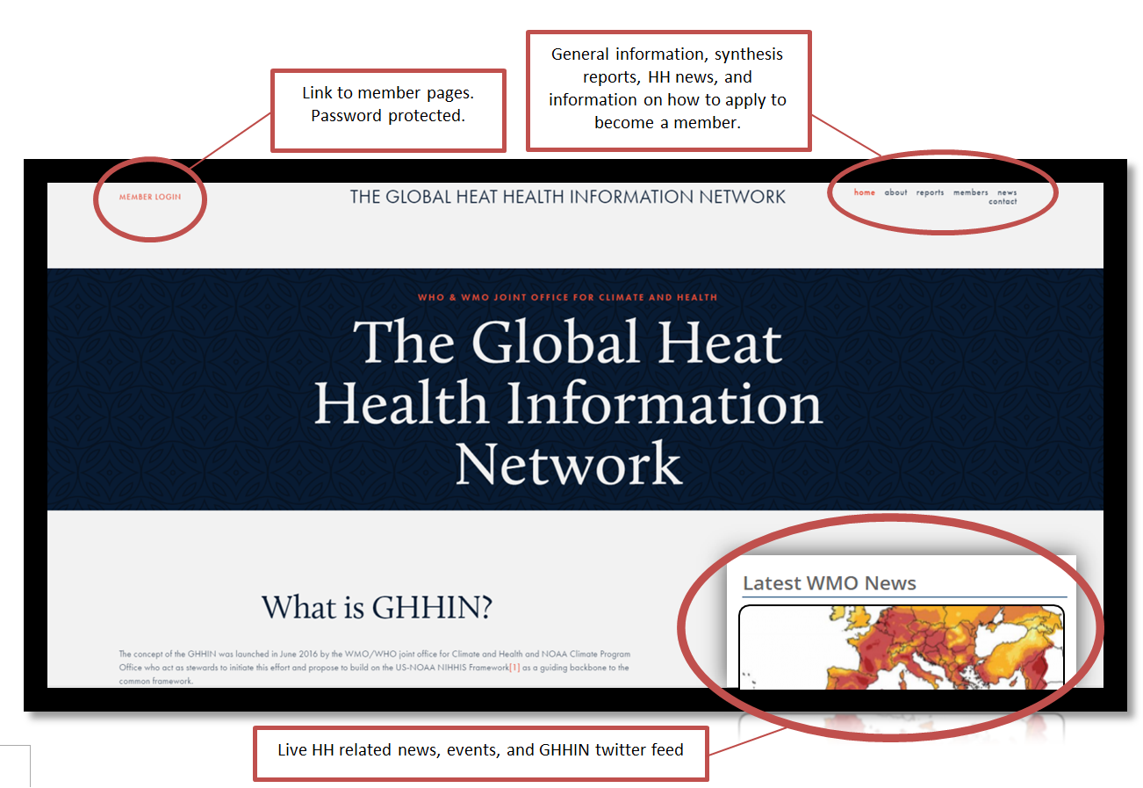 – Example GHHIN home webpage

**Appendix 4** – Changes in responsibilities over time

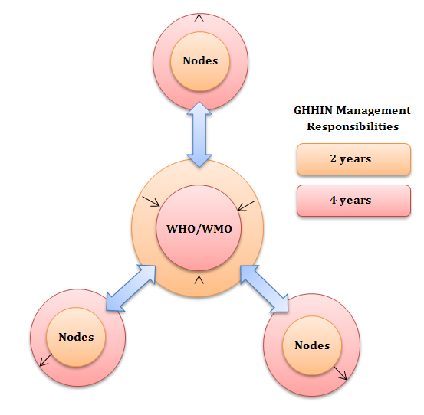

**Appendix 5**– Example regional node page

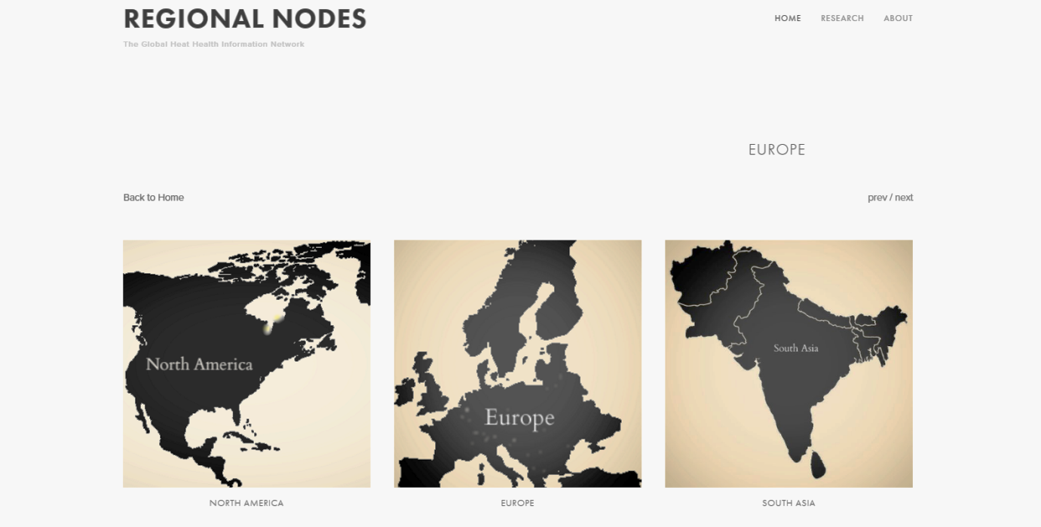

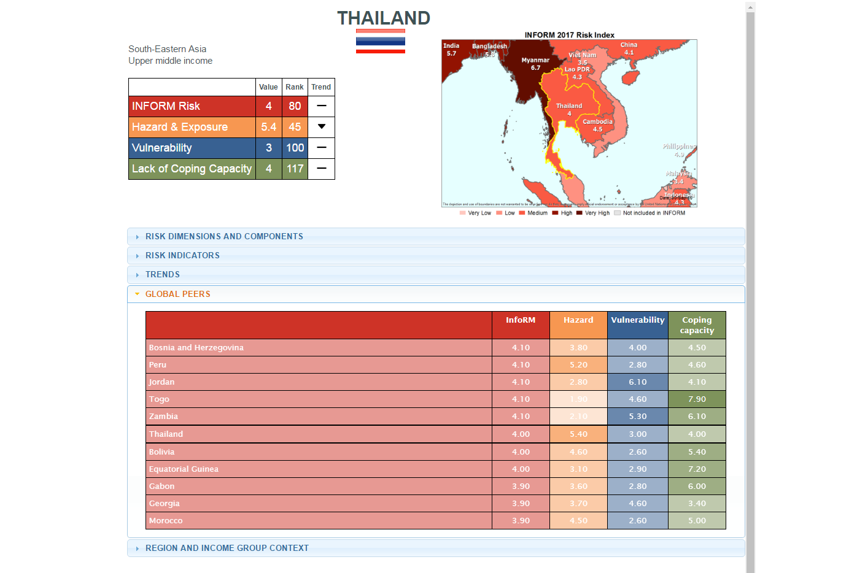 **Appendix 6** – Country profiles

Demographics, and trends.

Zone

Heat #

Heat Risk Score.

Geographic Zone – to identify similar climates.

**Appendix 7** – Country profile: gather trends in heat and adaptation over time – display on the public site.

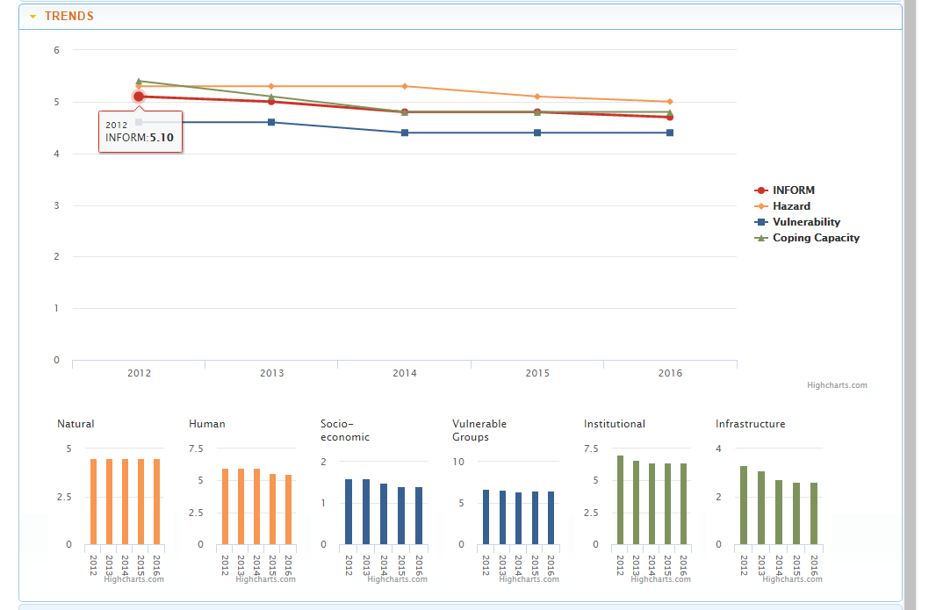

**Appendix 8** – Example GHHIN members home page

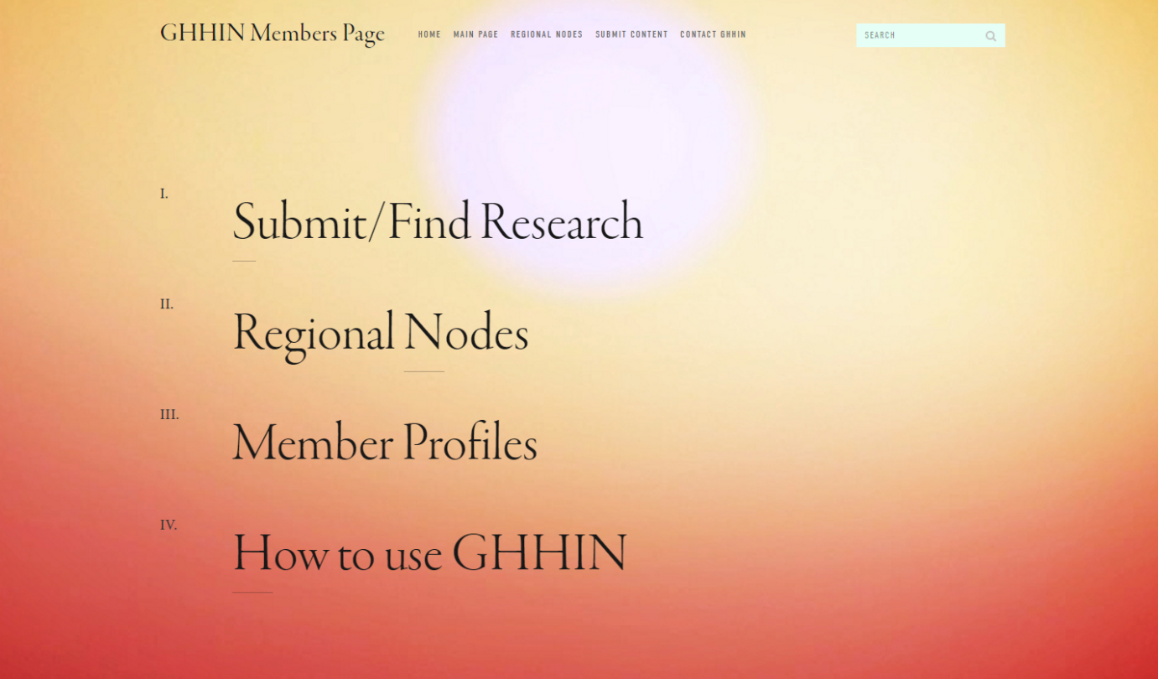

GHHIN News

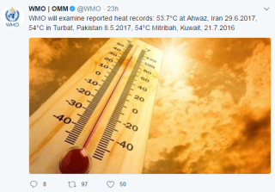

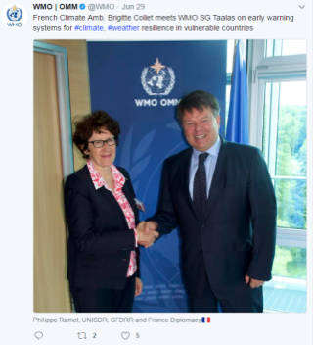

Also included on front page dashboard: Global heat forecast,

Calendar, shareable content

**Appendix 9**: Synthesis and Conference Report database (accessible to the public and members)

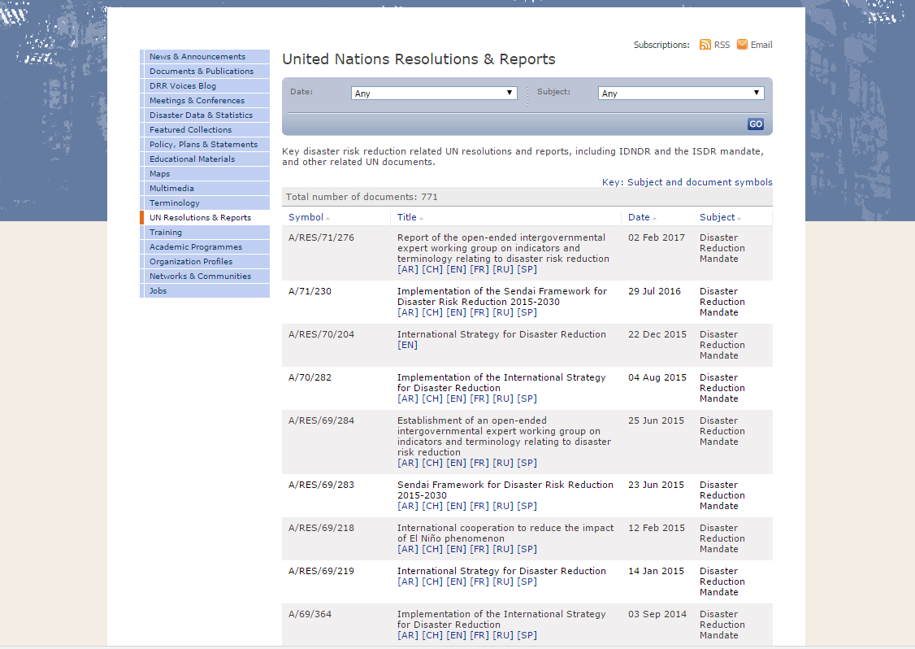

GHHIN Synthesis & Conference Reports

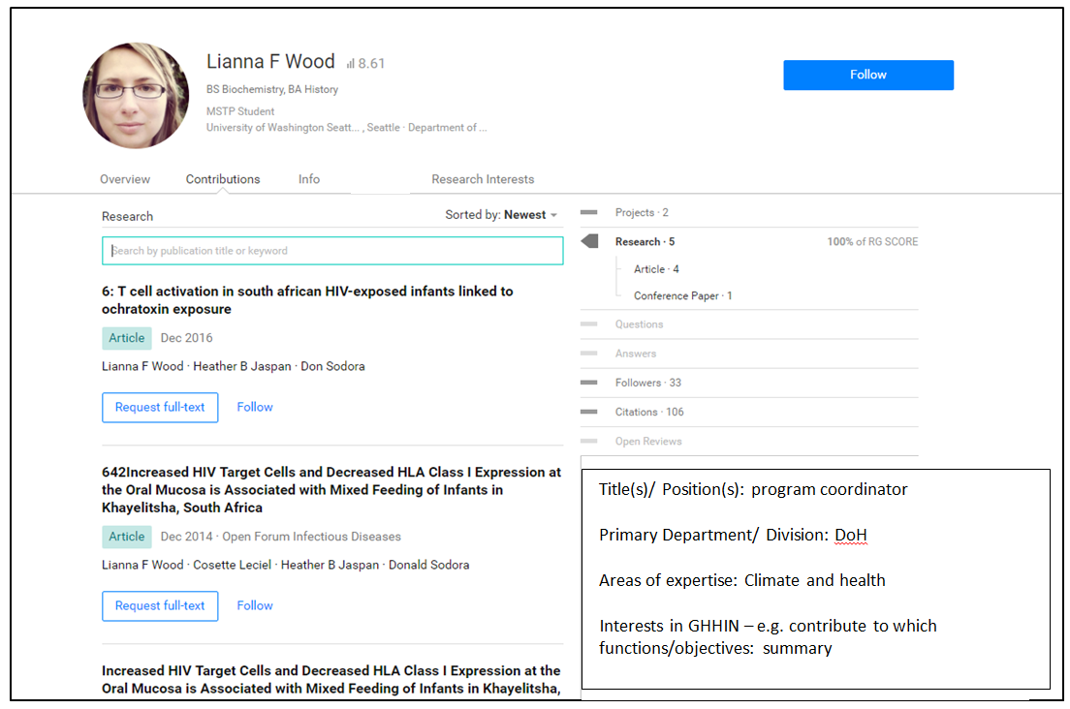 **Appendix 10**: Member profiles example

Appendix - Timeline

The GHHIN website and services will be established in their initial form in 2017. The network will be continuous updated as new content is created and adapted. Below is a rough timeline for the development and implementation of the website, services offered, outreach strategies, and shifting responsibilities. All changes will happen in a staggered format, prioritizing user-needed services and network sustainability.

# 2017

Approval of the design strategy and priority areas of work by the UNISDR Senior Leadership

* Development of the visual design and architecture for the basic site components
* Establishing GHHIN brand
* Targeted outreach
* Development and implementation of the 0-1 year services (appendix)

# 2018

* Management of the basic site
* Development and testing of the final site
* Development and implementation of the 1-2 year services (appendix)
* Establish regional nodes
* Targeted outreach
* Publication of the synthesis report
* Hold first bi-annual conference

# 2019 - 2021

* Implementation of the final site
* Development and implementation of the 2-4 year services (appendix)
* Establish independently managed regional nodes
* Transition of recruitment to region nodes
* Update and publish synthesis report
* Hold second bi-annual conference

Other:

Sites that we should ask to link to our portal/main page (Linked to the WMO pages)

Photo contest – credit people, original

Heat Health contest – take selfie of doing a heat health community project?

Quizzes that disseminate data (individual level quiz on the main site).

Where do you go, what do you do, etc. etc.

Shareable information/”suck the information out” to populate their figures.

Projects to look at:

https://connect.innovateuk.org/